### **PPT Link -** [**PPT**](https://docs.google.com/presentation/d/1IVQhkGDZSygKMXlXWa4TjncjJzb9ze0oEMlFUhV4DQQ/edit?usp=sharing)

**Video Link -** [**Video**](https://drive.google.com/file/d/14ykFxOgiCrCEhIOZ1SGQca59p6GLOHf-/view)

### 

### 

### 

### 

### 

### 

### 

### 

### 

### 

### **Child Tracker With Emergency Notifications Using IBM Cloud**

| * Submitted by   19BAI10017 - Shanzeh Batool  19BAI10088 - Mohd Nazim Ansari  19BAI10038 - Juhi Shaw  19MIM10063 - Pratham Barot |
| --- |

1. Introduction
2. Overview

Child tracker helps the parents in continuously monitoring the child's location. They can simply leave their children in school or parks and create a geofence around the particular location. By continuously checking the child's location notifications will be generated if the child crosses the geofence. Notifications will be sent according to the child's location to their parents or caretakers. The entire location data will be stored in the database.

The web application will have the following features:

1. Connect to IBM IoT platform and get the location data
2. Display the location in Google map
3. Check whether the child is inside the geofence or not
4. Send the notification if the child goes out of the geofence
5. Store all the location data in the cloudant DB

b. Purpose

To make an online child tracker which can help parents and caretakers to keep track of their child’s location by send emergency notifications whenever their child crosses the geofence. Also, by using this, parents can track their child’s location at any point of time whenever they feel like doing so.

2. Literature Survey

1. Existing Problem

Sometimes some parents need to take care of their children, as they are worried about then

that either, they may go somewhere and get lost or maybe someone can kidnap them. So,

there was a need of a child tracking system, so the parents can feel secure and concentrate

on their work calmly.

1. Proposed Solution

Here, we present to you an online child tracking system, which would immediately send

emergency notifications whenever the child is out of the geofence. Also, parents or

caretakers can check the location of the child whenever they feel like doing it. This child

tracking system makes excellent use of the available resources on the internet and gives

amazing output. Here, we use the IBM cloud, NODE-Red, and python code to successfully

implement our proposed solution.

3.Theoretical Analysis

1. Block Diagram

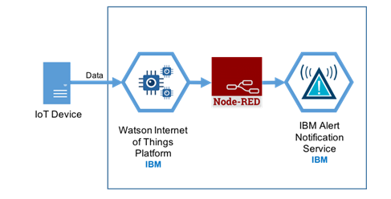

1. Hardware / Software Designing
2. IBM Cloud

NODE RED Service.

Cloudant Service.

1. IBM IoT Platform.
2. Free2sms service.
3. Visual Studio Code.
4. Wiotp.sdk.device,json,time library.

4. Experimental Investigations

1. Develop the web application using Node-RED
2. The web application should have the following features:
   1. Connect to IBM IoT platform and get the location data
   2. Display the location in Google map
   3. Check whether the child is inside the geofence or not
   4. Send the notification if the child goes out of the geofence
   5. Store all the location data in the cloudant DB
3. Connect to IBM IoT platform and get the location, store the data in cloudant DB.
4. Integrate the geofence to check if the child is inside or outside the geofence and display the location in google map.
5. Send the notification if the child is out of geofence.

Project Flow:

1. The GPS coordinates of the child will be sent to IBM IoT platform
2. Location can be viewed in the Web Application
3. Parent can create a geofence in the web application
4. Web application will check if the child is inside or outside the geofence
5. Notifies the parents if the child goes out of the geofence.

5.Flowchart

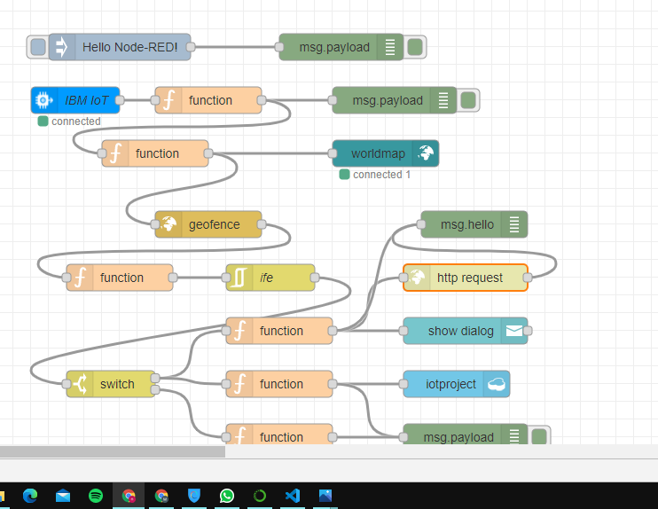

6. Result

After implementing our proposed model, we were successful in tracking the location of the child and sending notifications, to the registered mobile number (of the parent or the care taker), whenever the child was out of the geofence area.

7. Advantages

1. Increased safety
2. More independence
3. Carer costs minimized
4. Prolong living in own home
5. Can maintain more of their normal routines
6. Peace of mind for loved ones.

8. Disadvantages

Sometimes GPS may fail thanks to certain reasons and therein case you would like to hold a backup map and directions.

If you’re using GPS on A battery operated device, there could also be A battery failure and you’ll need an external power supply which isn’t always possible.

Sometimes GPS signals aren’t accurate thanks to some obstacles to signals like buildings, trees, and sometimes by extreme atmospheric conditions like geomagnetic storms.

GPS chip is hungry for power which drains the battery in 8 to 12 hours. this needs replacement or recharge of battery quite frequently. GPS doesn’t penetrate solid walls or structures. it’s also suffering from large constructions or structures

9. Applications

1. Parents/Caretakers/Teachers can use this for tracking the location of their child.
2. It can be used for tracking the location of any particular object too, like their personal car.
3. Suspicious activities can be monitored, analysed and reported as soon as the object of value goes out of the specified range.

10.Conclusion

Child GPS Tracking System helps parents monitor their children and ensures child’s safety. Some of the best works implemented in past rely on SMS-based tracking which is not helpful to get an accurate location, but in our proposed system we have provided real-time tracking. We have added Geo-fencing and Emergency messaging services to enhance the system.

Whenever the child leaves the geofenced boundary an emergency message will be sent to the parent. And also if the parent wants to know the recent places visited by the child, they can see through this app. Therefore, we can conclude that this application

provides a solution for children missing and this paper takes the advantages of smartphones which offer rich features like Google maps,

GPS, SMS, etc.

11.Future Scope

This project concentrates on following a child's position and its location is sent to the guardians, versatile. It can be reached out to all children by diminishing size of child module as little chip which gets settled to the id card. It can likewise be adjusted by implying the missing kid data to the police control room. A camera can likewise be added to the child module.It can also be utilized for girls women well being is imperative these days.

12.Bibliography

1. Putri Rafflesia, Firdaus, Dinda Lestarini, “An Integrated Child Safety using Geo-fencing Information on Mobile Devices", INTERNATIONAL CONFERENCE ON ELECTRICAL ENGINEERING AND COMPUTER SCIENCE (ICECOS) 2018.

2. <https://smartinternz.com/Student/guided_project_info/6898#>

11.Appendix

1. Source Code

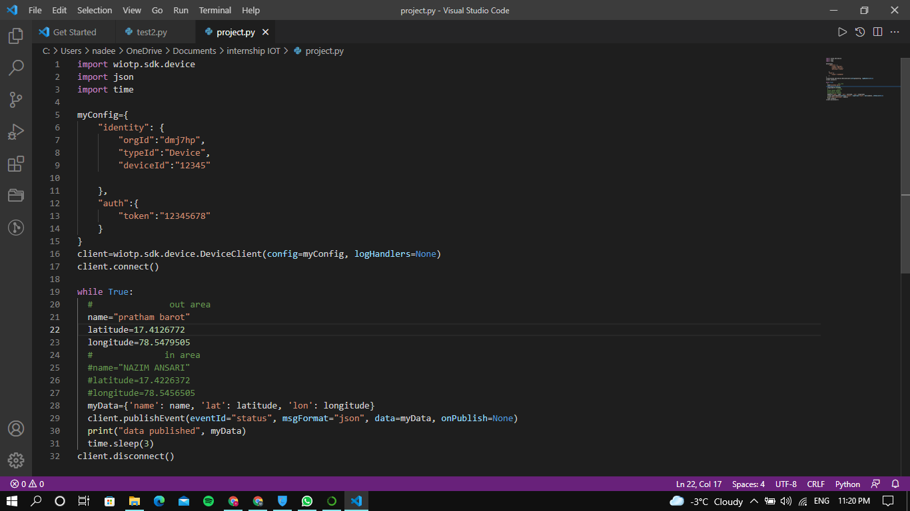

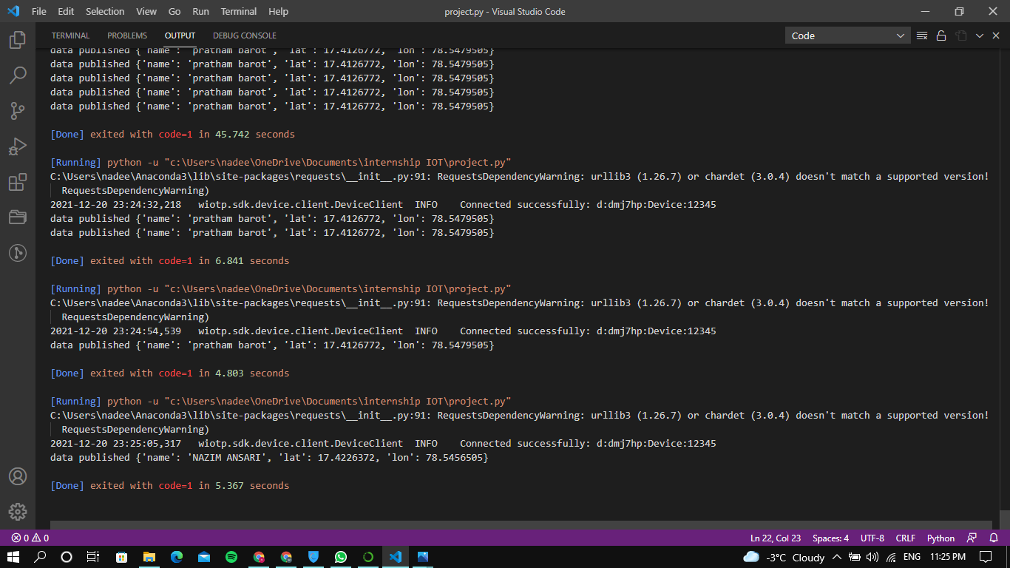

1. Output Screenshot

